MED D - Test Claim - Calculating Quantity of Nebulizer Solutions

Definition | A nebulizer solution is a solution (liquid) of medication to inhale by mouth using a nebulizer (machine that turns medication into a mist that can be inhaled).  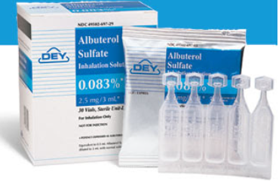  Be careful not to confuse a Nebulizer Solution with a Liquid, Inhaler or Nasal Spray.
Instructions for Running a Test Claim | How many total vials does beneficiary use each day?  What day-supply is needed?
What if Test Claim Rejects | Review the rejection code to determine what caused the rejection. Once the rejection code is identified, access the proper work instruction and job aids in theSource to help you resolve the issue.

Example
Albuterol Sulfate Neb Sol
0.63mg/3ml

Directions: Use 1 vial 3 times daily
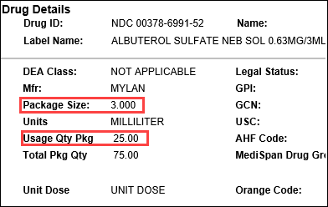 |  |  | 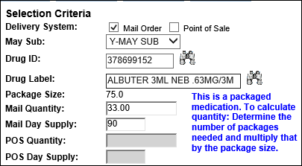
Calculation
Vials per Day | X | Days |  | = | Vials Needed
3 | X | 90 |  | = | 270
Vials Needed | ÷ | Usage Quantity Package  (from PeopleSafe) |  | = | Total Packages Needed
270 | ÷ | 25 |  | = | 10.8 (Round up to 11)
Total Packages Needed | X | Package Size  (from PeopleSafe) |  | = | Test Claim Quantity
11 | X | 3 |  | = | 33

Top of the Document

Related Documents
MED D - Test Claim Index
Calculating Quantities for Packaged Medication

Parent SOP: CALL-0049: Customer Care Internal and External Call Handling
Abbreviations / Definitions: Customer Care Abbreviations, Definitions, and Terms

Top of the Document

Not To Be Reproduced Or Disclosed to Others Without Prior Written Approval
ELECTRONIC DATA = OFFICIAL VERSION – PAPER COPY – INFORMATIONAL ONLY

